"Instead of applying try-catch in all controllers, we can use **Global Exception Handling**."

[Route("api/[controller]")]

[ApiController]

public class StudentController : ControllerBase

{

string[] students = new string[] { "John", "Jane", "Doe" };

[HttpGet]

public async Task<IActionResult> GetAllSutdents()

{

try

{

//throw new Exception("Error occured");

Console.WriteLine(DateTime.Today);

Console.WriteLine("Hello world");

return Ok(students);

}

catch (Exception ex)

{

// Log the exception to console (not implemented here)

return StatusCode(StatusCodes.Status500InternalServerError, "An error occurred while fetching students.");

}

}

}

}

//return StatusCode(500, "error occured");//Hardcoded value

//return StatusCode(StatusCodes.Status500InternalServerError, "error occured");//Named constant use

**🔹 Why? (Real-World Logic)**

Agar har controller me try-catch likhenge to:

* Code repetitive ho jaayega
* Maintenance difficult ho jaayega

👉 Isliye **Global Exception Handling** ka use hota hai — ek central jagah pe sab errors handle ho jaate hain.

🔧 **ASP.NET Core Web API me Global Exception Handling kaise setup karein:**

✅ Step 1: Create middleware class

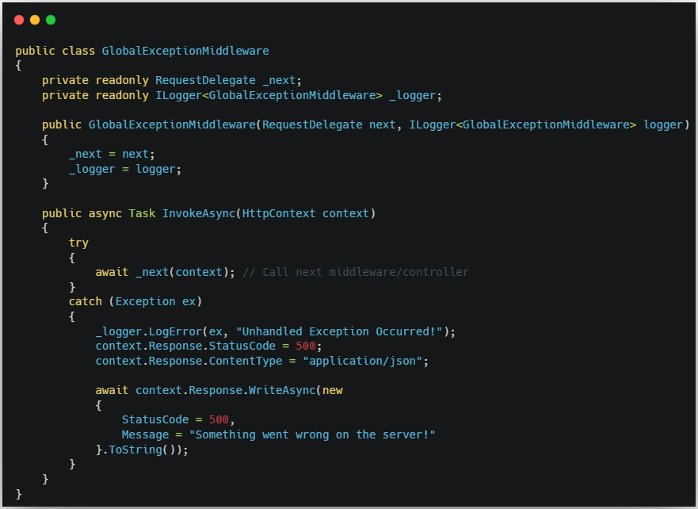

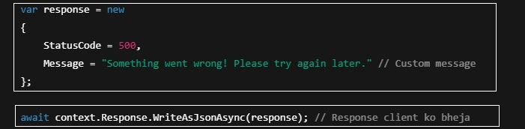

✅ Step 2: Register middleware in Program.cs before UseHttpsRedirection()- not recommended



👉 Iske baad har unhandled exception middleware me catch ho jaayega.

**🔸 Benefits:**

* ✅ Code clean & DRY
* ✅ Centralized error logging
* ✅ Easy to log with Serilog or ILogger
* ✅ Custom error responses ban sakte hain

🔧 **Controller Before (Without Global Exception Handling):**

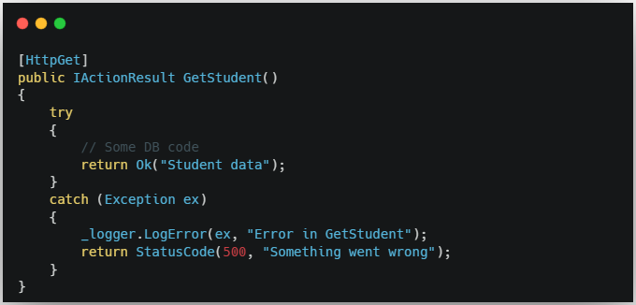

🔧 **Controller After (With Global Exception Handling):**

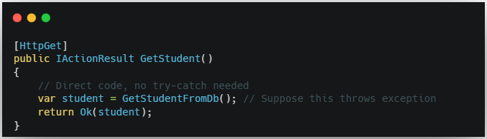

⚠️ Agar GetStudentFromDb() me exception aayega to wo automatically **Global Middleware** me handle ho jaayega.

🔹 **Global Exception Handling** ek **ASP.NET Core ka mechanism** hai — jisko **custom middleware** ke through implement kiya jata hai.  
🔹 **Serilog** sirf ek **logging tool** hai — jo aapki middleware me **exceptions ko log** karne me help karta hai.

**🧠 Relation samjhiye:**

* ASP.NET Core → middleware ke through error ko **catch** karta hai
* Serilog → us error ko **log file me likhta hai**

### ✅ Summary:

| **Feature** | **Belongs to** |
| --- | --- |
| Global Exception Handling | ASP.NET Core |
| Logging in file/console/db | Serilog (3rd-party) |